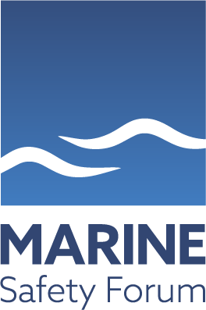

All Members Webinar
24th November 2020
MSF Chairman Introduction – 10.15
Police Scotland – Maritime Security 10.30
Step Change – Enclosed Space 11.00
&
25th November 2020
Nippin Anand – Near Miss Reporting 11.00

Please follow the link below to join

https://zoom.us/j/96248165332

All our members are, as always, extremely welcome to join us, especially seafarers and offshore installation workers, for whom the MSF continue to strive to provide, and improve, an everyday safe working environment.

If you have any queries please email: -
secretary@marinesafetyforum.org

